**1.INTRODUCTION**

As we know that education is one of the most importantissues all over the world. The context is the comprehensive scenario in which institute compete for higher enrollment with each other. now a days DSS are the most efficient tool to deal with any kind of situation, where the decision are required to be taken efficiently.

This result is need for the support for various phases in the admission pocess. Enterprice resource planning system provide a solution due to fragmented databases, revenue , tracking, centralization, inventory, optimization, etc….In admission process the phases related to the generation of information as follows:

1.Application for a course

2.Examination

3.Assesment and Evaluation

4.Selection of students

In higher education environments, data mining and DSS are well suited technologies to provide decision support by generating and presenting the relevant information and the knowledge toward quality improvement of education process .



* 1. **OVERVIEW**

University admission is the process by which student are selected to attend a college or University. The process typically involves several steps, including submitting an application, taking entrance exams and participating in interviews or other evaluations.

Students are often worried about their chances of admission University. The university admission process for students can be demanding, but by being well-informed, prepared and organized, students can increase their chances of being admitted to the University of their choice.

The aim of this project is to help student in short listing universities with their profile. Machine learning algorithm are then used to train a model on this data, which can be used to predict the chances of future applicants being admitted. With this project, students can make more informed decision about which university to apply to, and university can make more efficient use of their resource by focusing on the most promising applicants. The predicted output gives them a fair ideas about their admission chances in a particular university.

* 1. **PURPOSE**

Artificial Intelligence is gradually gaining acceptance from colleges and universities as an effective tool to automate a variety of tasks; be it the use of chatbots for answering student queries, or the AI driven messaging system that reminds students of overdue assignments and deadlines; be it a prompt for paying their fees on time or for doing a plagiarism check on their submissions, AI is finding its place in the corridors of higher education. Higher education is now advancing from its initial foray into digitalization – from just automating routine tasks to handling more complex projects, to do stuff that help them grow and compete. Higher education is gradually moving to operate like an open economy – hordes of suppliers, plethora of service seekers – where

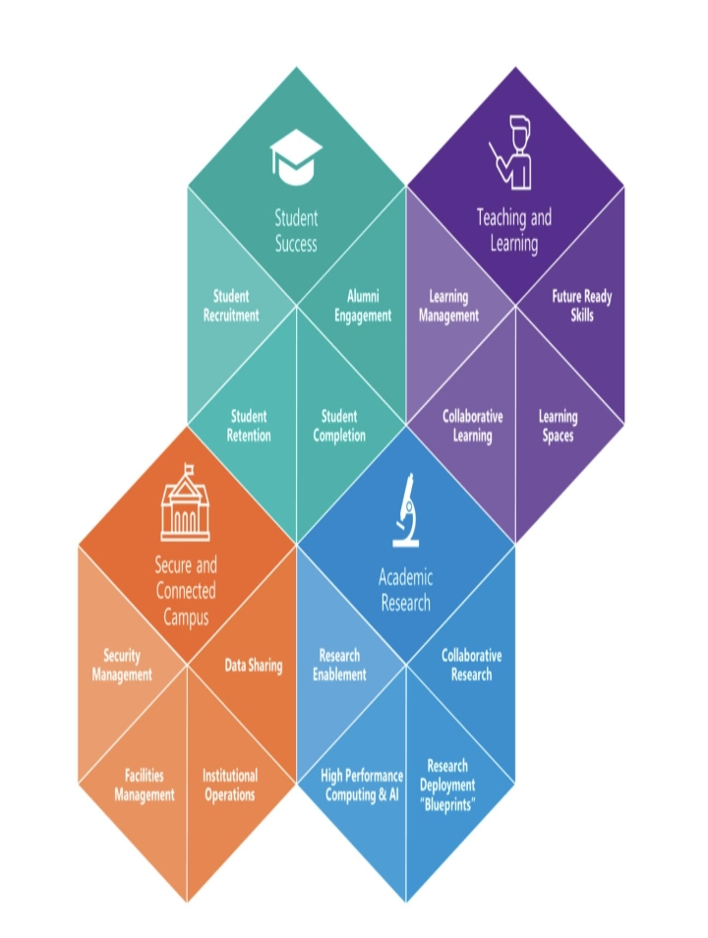

only the best wins! It would be important for colleges and universities to market their products and services well and target the candidate early on! Artificial Intelligence and Machine Learning technologies can help colleges improve their student enrolments by five different ways!

Predicting student applications; There is an increasing realization amongst universities that they would benefit from an ability to predict with accuracy the number of applications that they must accept to hit prime enrolment numbers; over enrolment can stretch their resources too thin (number of faculty, lecture rooms, hostel facilities etc) and can negatively impact student experience while under enrolment can lead to reduced tuition revenue and an inefficient use of expended resources. ML tools can look at individual applicants based on identified metrics like high school grades, test scores, socio-economic backgrounds etc, examine trends based on previous year data and predict their probability of accepting admission. Additionally, ML models can predict with higher accuracy over archaic calculative models, which students will most likely succeed in a course.

Helping students identify the right courses; Students can find it challenging to navigate the catalog of courses to find the right fit for their skills and experience. Without consultation and assistance, the process can be challenging and result in disillusionment and lower enrolment rates. Meanwhile, providing personalized counseling to thousands of users requires human resources that would go beyond the institute’s capacity and budget. AI powered chatbots can provide

guidance and quick responses to questions thus helping students make

the right choices. NLP based chatbots that enables the platform to

analyze and respond to the meaning behind human-generated text,

enable their users to interact with them in a comfortable,

conversational fashion. This provides students with an experience

similar to what they would get from talking to a counsellor instead of

manually finding their way around the courses.

**2. PROBLEM SOLVING AND DESIGN THINKING**

**2.1 EMPATHY MAP**

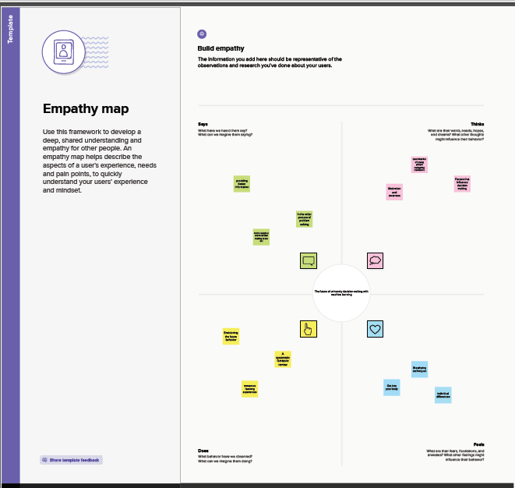

**2.2 IDEATION AND BRAINSTROM MAP**

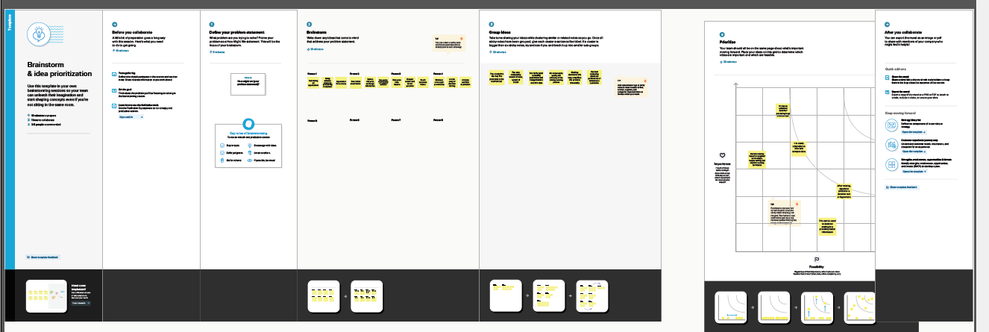

**3. Result**

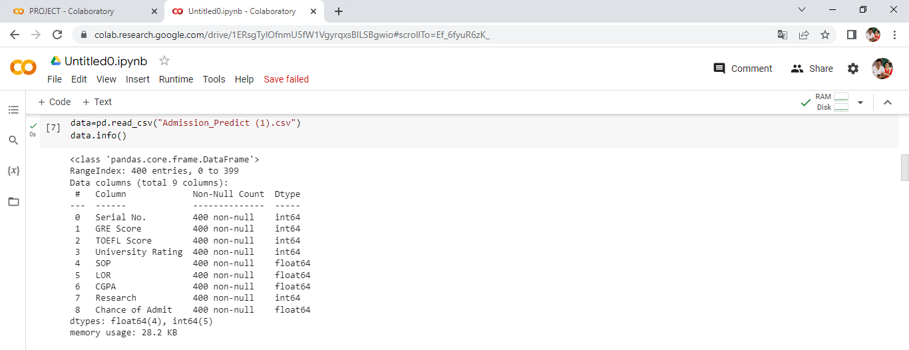

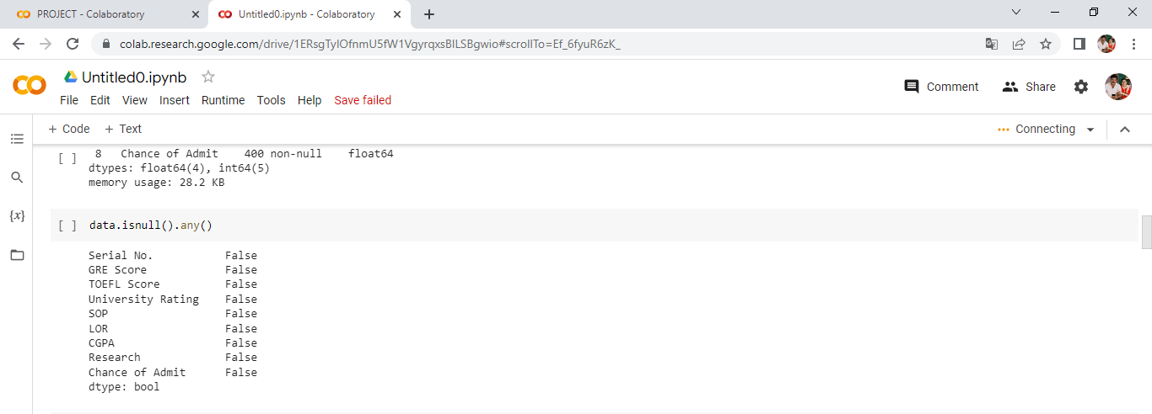

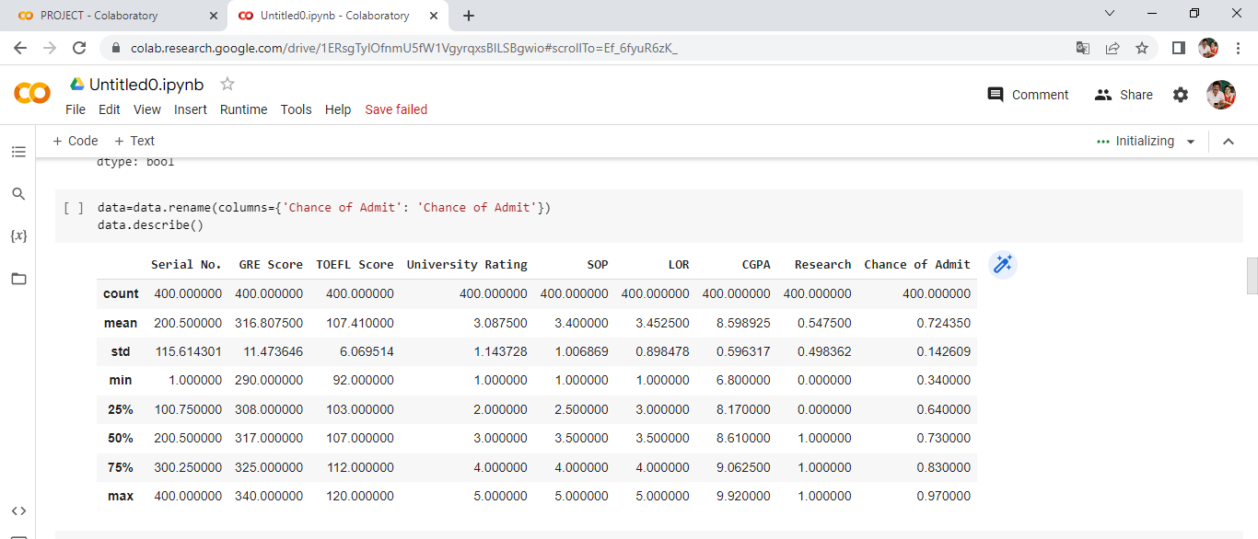

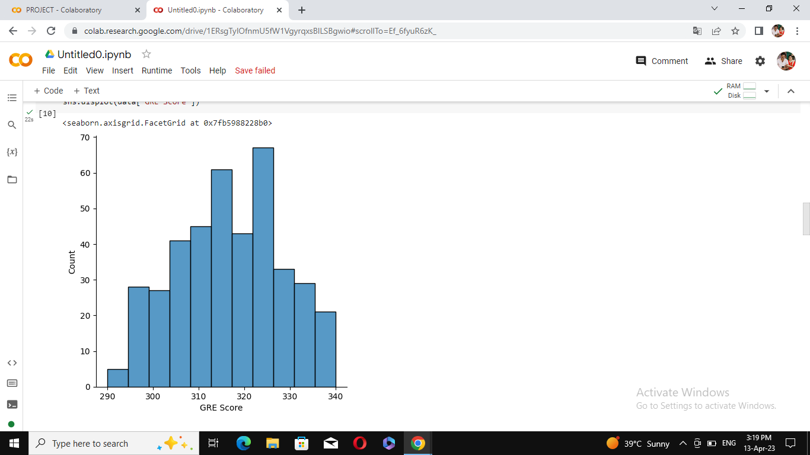

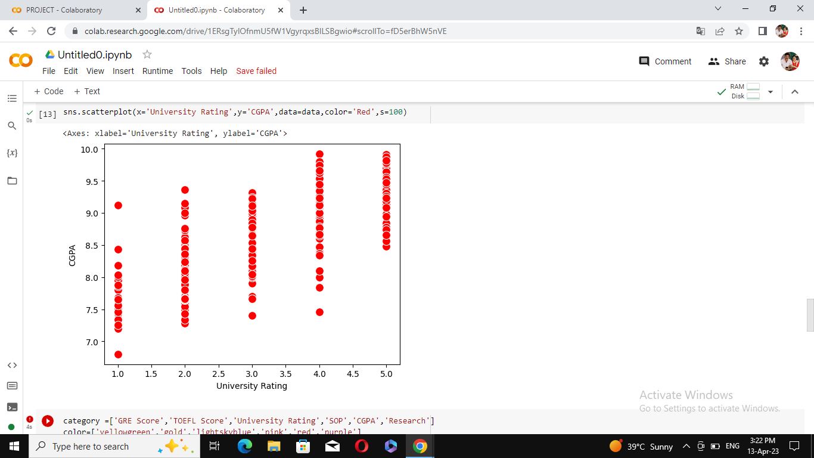

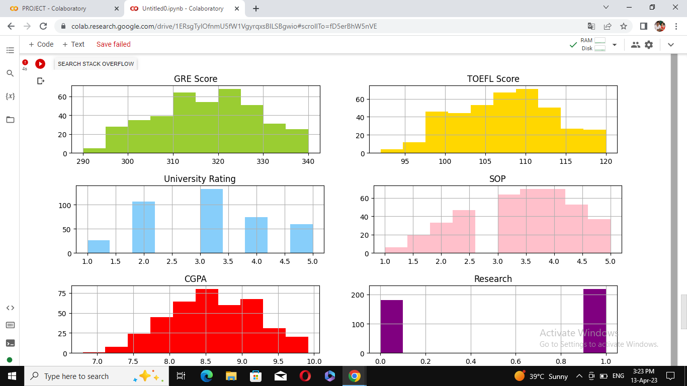

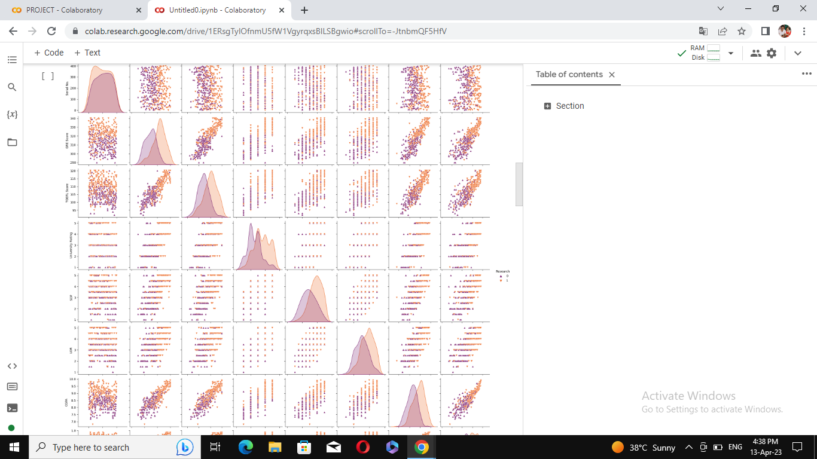

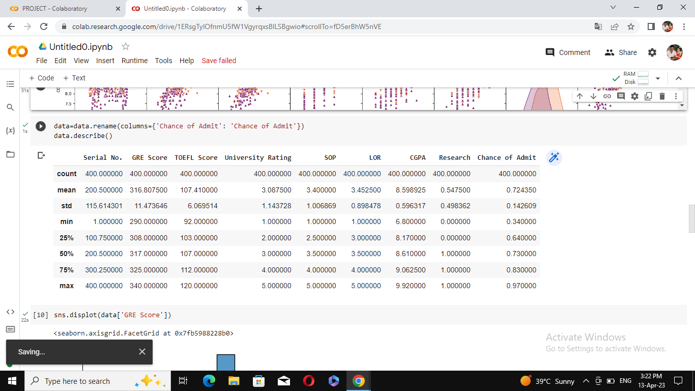

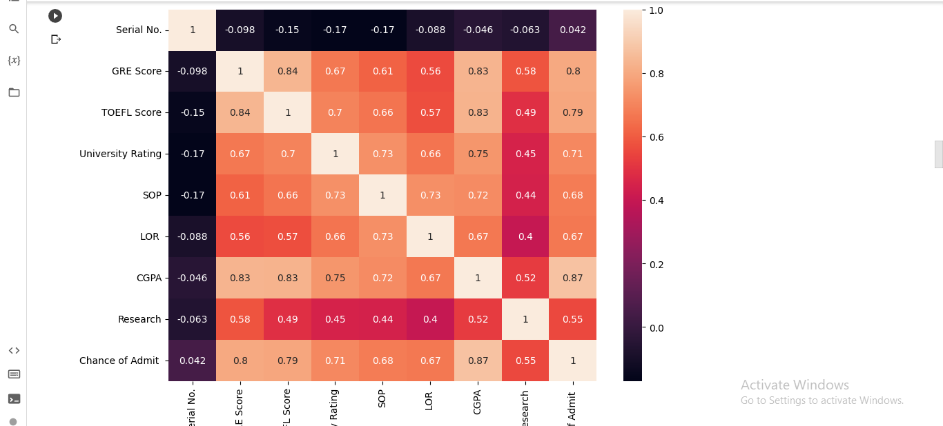

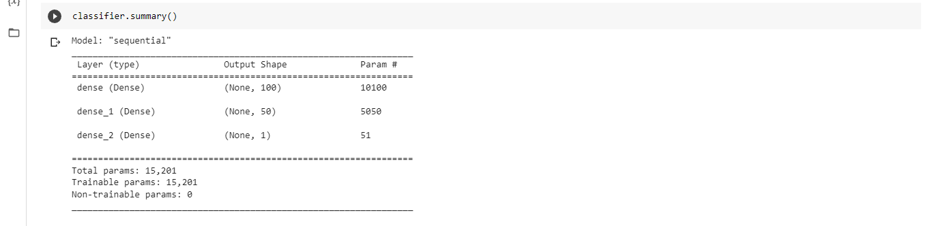

**4. ADVANTAGES AND DISADVANTAGES**

**ADVANTAGES**

[1) Student acquisition](https://ischoolconnect.com/blog/5-benefits-of-ai-in-higher-education-technology/#1-student-acquisition)

[2) Operational efficiency](https://ischoolconnect.com/blog/5-benefits-of-ai-in-higher-education-technology/#2-operational-efficiency)

[3) Classroom learning](https://ischoolconnect.com/blog/5-benefits-of-ai-in-higher-education-technology/#3-classroom-learning)

[4) Student engagement](https://ischoolconnect.com/blog/5-benefits-of-ai-in-higher-education-technology/#4-student-engagement)

[5) Reminders](https://ischoolconnect.com/blog/5-benefits-of-ai-in-higher-education-technology/#5-reminders)

The influence of AI in higher education has been rapid and

widespread. The impact of Artificial intelligence is undeniable and

evident from the way faculties nowadays teach and students learn.

Already, smart AI tech. can complete a diverse set of varying tasks. So

what impact does it have on uber important and ever-changing sector

of higher education?

**1.Student Acquisition**



**2) Operational efficiency**

Researchers have been flirting with the use of artificial intelligence in

higher education for quite a few years. And the outcome is the use of

tools such as document recognition, essay and SOP graders, and

chatbots in higher education. AI tech like these could use information

from multiple campus systems to guide administrative decisions and

tailor the university curriculum toward employers’ hiring needs. Thus,

increasing the university’s operational efficiency.

**3) Classroom learning**



Artificial intelligence majorly assists classroom learning by providing a

comprehensive educational experience. It allows students to expand

their imaginations with tools and technologies such as augmented

reality and virtual assistants. These Classroom Assistance technologies

for grading and monitoring help the faculty enhance the educational

experience and get more out of their class time with the students.

**4) Student engagement**

AI technologies such as the interactive assistants allow students to

communicate their issues right when they crop up consequently, increasing

student retention rates. Student engagement can also be advanced by

embracing unique AI tech like the student success prediction models. Tech.

like Chatbots in higher education also helps educators improve their

efficiency in teaching based on the student opinions collected by the

conversational assistants.

**5) Reminders**



Conversational AI chatbots are used by institutions to interact with

studentsand send them relevant reminders

With the help of AI tech in higher education, institutions can aid

studentsby sending them helpful emails, text messages or push

notifications. These act as gentle reminders for when certain tasks

need completing, deadlines are approaching or events are coming up.

Such uses of AI will help students familiarise themselves with the tech

which will consequently, increase

student engagement.

**DISADVANTAGES**

Some disadvantages should be considered before the implementation of these technologies becomes commonplace across the country.

One major disadvantage posed by artificial intelligence applications relates to privacy concerns associated with uploading sensitive information into cloud-based databases that may not have sufficient security measures in place.

Another concern regarding the widespread use of this technology pertains specifically to education: students who do not learn how machines work will find themselves at a significant disadvantage if their field relies heavily on computer science skills going forward because they would lack the necessary knowledge.

Some of the major cons of artificial intelligence in education are listed below.

**Human Interaction Decreases**

Artificial intelligence can be a great tool in education, but there are some

disadvantages. One disadvantage is that students lose the ability to practice and

learn social skills because they don’t come into contact with real people during

class time.

This makes it hard for them when they get out of school and need these types of

interactions on the job or even just socially as adults.

**Unemployment of the Teachers**

One of the disadvantages that come with using AI in education is teachers losing their jobs. Since these programs help students learn on their own, there’s no longer a need for human instructors to guide kids during lessons or even grade assignments.

One of the disadvantages that come when artificial intelligence (AI) is used in schools is unemployment among teachers since computers can teach children without humans intervening and grading tests also lowers workloads compared to having more than one instructor per student thus making it less necessary for multiple people involved.

From a school administration perspective as well which might lead to layoffs if the number of employees becomes too much smaller due to this change over time

leading to lower salaries done by future administrations.

**Financial Problems**

Artificial intelligence in education faces a lot of financial problems. Artificial intelligence is designed by well-educated scientists who have studied for many years to perfect their craft, and they need money to continue their research as well as to pay employees that work on the projects with them.

Artificial intelligence may provide some benefits for education, but there are Disadvantages too. One of the main disadvantages of artificial intelligence in education is financial problems.

There will be a need to cover expensive costs when purchasing hardware and software that can support AI capabilities such as facial recognition or natural language processing tools which would make it very difficult for school systems with little funding to implement these technologies into their classrooms

**Data Problems**

AI has challenges with data collection and will need to face some big issues moving forward.

The disadvantages of artificial intelligence in education include data problems. It’s not possible to anticipate all the ways students learn, and it is difficult for teachers to find a single algorithm that will meet everyone’s needs.

AI needs a lot of information in order for the computer program to learn properly, but there are many problems that come along with this process.

**5.APPLICATIONS**

* Vellore Institute of Technology (VIT):



* Chandigarh University:



* Jain Deemed to be University:



* SRM Institute of Science and Technology:



* Dy Patil International University:



* Sharda University:



**6. CONCLUSION**

In this paper, the authors illustrated the activities regarding admissions in the higher institutes

where decision support systems are required for taking the admissions. The final section

comprises the proposed architecture of Decision Support System, a modern approach to the

decision making processes. ERP with IDSS provides good support for decision making otherwise

the limitation of ERP will reduce the effectiveness system of decision making.

Future work will focus on implementing the proposed architecture for the education system.

In addition Specific Data Mining Techniques like Clustering can Profile Student intake and

identify Promising Groups for Targeting in future intakes. Decision Trees can identify Loan

needy students. Integrated educational Planning in the area can thus be facilitated by drilling

down the Data to Schools in the area.

In this paper, the authors illustrated the activities regarding admissions in the higher institutes

where decision support systems are required for taking the admissions. The final section

comprises the proposed architecture of Decision Support System, a modern approach to the

decision making processes. ERP with IDSS provides good support for decision making otherwise

the limitation of ERP will reduce the effectiveness system of decision making.

Future work will focus on implementing the proposed architecture for the education system.

In addition Specific Data Mining Techniques like Clustering can Profile Student intake and

identify Promising Groups for Targeting in future intakes. Decision Trees can identify Loan

needy students. Integrated educational Planning in the area can thus be facilitated by drilling

down the Data to Schools in the area.

This development will emphasize the high level of educational

technologies in Ukraine and the world. Not only entrants will

benefit from it, but also providers of educational services

(universities, online educational platforms, and academies). In

particular, the latter will increase the number of applicants for degrees,

users, and students, analyze the target audience, provide a more

personalized learning path in the future, and create competitive

educational services.

Given the results obtained, consultations for higher educational

institution representatives in Ukraine, particularly departments,

research institutions, and participants in career guidance campaigns,

will be beneficial. These sessions will contribute to a better

understanding of the decision-making process of Ukrainian university

entrants and allow better targeting of individual school graduate

cohorts.

For entrants, the benefits are pretty obvious: the ability to choose an

educational program for themselves, considering their interests, skills, budget, and location. Additionally, one of the key goals is to provide

self-awareness in a specialty to study. After all, as seen in popular

specialties, many entrants apply there only because they are well-

known. This pattern can have a detrimental effect on the market

professionals’ quality, labor market trends, as well as entrants and their

financial resources.

In further research, we suggest accomplishing the following:

Develop automated solutions to find similar and alternative specialties.

Carry out data augmentation of a successfully selected specialties itemset to provide better and more unique, personalized

recommendations to entrants.

Identify and increase entrants’ awareness when choosing a place to study.

This problem is especially relevant during the COVID-19 crisis when,

due to a lack or poor quality of communication with the surroundings,

entrants are unable to attend career guidance events, get acquainted in

detail, and discuss the admission rules for a particular specialty.

It is necessary to mention the military and geopolitical situation in

Ukraine because the appropriate choice of specialty will support and

accelerate the development and reconstruction of the country in the current and postwar periods. Given the current war situation in Ukraine

and the Russian aggression, much damage has been inflicted on

domestic industries, and companies must stop operations in hostile

zones. In addition, many infrastructures were destroyed. Accordingly,

the need mentioned above for young professionals to rebuild the

country is critical. Thus, the recommendation system will allow entrants

to choose those specialties that will allow them to be most helpful to

the state and meet their interests and preferences. After all, a person

needs to do what brings joy and, at the same time, value.

**7. FUTURE SCOPE**

It is evident in today’s world that there is a vast influx and birth of

University institutions that has flooded the internet or the World Wide

Web (WWW), and many of them lacks accreditation and credibility. But

with mobile agent technology these vulnerabilities can be adversely

and greatly reduced. Mobile Search Agents can be used to verify and

validate an accredited university within the applicant’s geographical

location. Once a university name is obtained, the agent automatically

sources the information from accredited government and regulatory

bodies’ databases and websites in that countries locality to ascertain

the validity and accreditation of the named university body. Ranking

systems for world universities such as Shanghai Rankings, QS World

University Rankings, Times Higher Education Reputation Rankings and

Webometrics, are not ranking systems facilitating feedback ratings of

students based on a university’s education quality, research facilities,

fees, environment, customer service and security. So accordingly Agent

based system for Institutional search and Admission was developed

(Suresh and Cox, 2012) i.e Intel-EISAS that mitigates above mentioned

shortcomings. The system surrounds around Jamaican university and

college institutions towards search based on user’s criteria by applying

fuzzy preferences. Though the above mentioned Agent based system

saves time and efficient in selecting universities, but still it got some

drawbacks which are mitigated in current smart agent based system

developed in this research project. The results and tasks are generated

by autonomous agents designed in a way that allow for cooperation,

interoperability and communication within the system enabled the

coordination of the entire search, selection and admission process thus

allowing little or no human intervention resulting in a more time and

cost effective process. In future the system developed can be

integrated with agent learning capability which allows the agents to use

past information to assist in searching for institutions rather than

asking users to select all criteria. Also there is no payment feature as

this requires Security improvement. This requires added WAP services

in relation to credit card payments with the system.

**8.APPENDIX**

from google.colab import drive

drive.mount("/content/gdrive")

from google.colab import files

uploaded=files.upload()

import numpy as np

import pandas as pd

import matplotlib.pyplot as plt

import seaborn as sns

data=pd.read_csv("Admission_Predict (1).csv")

data.info()

data.isnull().any()

data=data.rename(columns={'Chance of Admit': 'Chance of Admit'})

data.describe()

sns.displot(data['GRE Score'])

sns.pairplot(data=data,hue=’Research’,markeers=[“v”,”^”],palette=’inferno’)

sns.scatterplot(x='University Rating',y='CGPA',data=data,color='Red',s=100)

category =['GRE Score','TOEFL Score','University Rating','SOP','CGPA','Research']

color=['yellowgreen','gold','lightskyblue','pink','red','purple',’Chance of Admit’]

start=True

for i in np.range(4):

  fig=plt.figure(figsize=(14,8))

  plt.subplot2grid((4,2),(i,0))

  data[category[2*i]].hist(color=color[2*i],bins=10)

  plt.title(category[2*i])

  plt.subplot2grid((4,2),(i,1))

  data[category[2*i+1]].hist(color=color[2*i+1],bins=10)

  plt.title(category[2*i+1])

plt.subplots_adjust(hspace=0.7,wspace=0.2)

plt.show()

**#scaling data**

from sklearn.preprocessing import MinMaxscaler

sc=MinMaxscaler()

x=sc.fit_transform(x)

x

x=data.iloc[:,0:7].values

x

y=data.iloc[:,7:].values

y

from sklearn.model_selection import train_test_split

x_train,x_test,y_train,y_test=train_test_split(x,y,test_size=0.30,random_state=101)

y_train=(y_train>0.5)

y_train

y_test=(y_test>0.5)

**#model building**

**Logistic Regression Model**

from sklearn.linear_model.logistic import logisticRegression

cls=LogisticRegression(random_state =0)

lr=cls.fit(x_train,y_train)

y_pred=lr.predict(x_test)

y_pred

**ANN Model**

import tensorflow as tf

from tensorflow import keras

from tensorflow.keras.layers import Dense,Activation,Dropout

from tensorflow.keras.optimizer import Adam

model=keras.sequential()

model.add(Dense(7,activation='relu',input_dim=7))

model.add(Dense(7,activation='relu'))

model.add(Dense(1,activation='linear'))

model.summary()

model.fit(x_train, y_train, batch_size=20,epochs=100)

**Testing the model**

model.compile(loss='binary_crossentropy',optimizer='adam',metrics=['accuracy'])

model.fit(x_train,y_train,bath_size=20,epochs=100)

from sklearn.metrics import accuracy_score

train_prediction=model.predict(x_train)

print(train_predictions)

train_acc=model.evaluate(x_train,y_train,verbose=0)[1]

print(train_acc)

test_acc=model.evaluate(x_test,y_test,verbose=0)[1]

print(test_acc)

print(classification report(v test.pred))

pred=model.pred.predict(x_test)

pred=(pred>0.5)

pred

**Compare the model**

**Logistic regression model**

from sklearn.metrics import accuracy_score,recall_score,roc_auc_score,confusion_,matrix

print(“\n Accuracy Score:%f” %(accuracy_score(y_test,y_pred)*100))

print(“Recall Score : %f” %(recall_score(y_test,y_pred)*100))

print(“ROC Score : %f\n” %(roc_auc_score(y_test,y_pred)*100))

print (confusion_matrix(y_test,y_pred))

**ANN model**

from sklearn.matric import accuracy_score,recall_score,roc_auc_score,confusion_matric

print(classification_report(y_train,pred))

from sklearn.metrics import accuracy_score,recall_score,roc_auc_meteic

print(classification_report(y_train,pred))

**Save the model**

model.save(model.h5)

**Building HTML pages**

**HOME HTML**

<html>  
<head>  
 <meta charset="UTF-8">  
 <meta name="viewport" content="width=device-width,initial-scale=1">  
 <meta http-equiv="X-UA-compitable" content="ie=edge">  
 <title>Home</title>  
 <link rel="stylesheet" href="https://maxcdn.bootstrapcdn.com/bootstrap/3.4.1/css/bootstrap.min.css">  
 <style>  
 body  
 {  
 background-image:url("https://i.pining.com/564x/18/d8/da/18d8da592a999a56398d34c38a1125c3.jpg");  
 background-size:cover;  
 }  
 h3.big  
 {  
 line-height:1.8;  
 </style>  
</head>  
<body>  
 <br>  
<div class="container">  
 <div class="row">  
 <div class="col-md-12 bg-light text-right">  
 <a href="/home" class="btn btn-info btn-lg">Home</a>  
 <a href="/predict" class="btn btn-primary btn-lg">Predict</a>  
 </div>  
 </div>  
 <center>  
 <h1><strong>INTELLIGENT ADMISSION</strong></h1>  
 </center>  
 <h3 class="big"><em>The purpose of intrlligent admission is to improve the future oh university to give a chance to student as a examining way</em></h3>  
</div>  
<script src="https://ajax.googleapis.com/ajax/libs/jquery/3.5.1/jquery.min.js"></script>  
</body>  
</html>

**Predict html**

<html lang="en">  
<head>  
 <meta charset="UTF=8">  
 <title>Predict</title>  
 <link rel="stylesheet" href="https://maxcdn.bootstrapcdn.com/bootstrap/3.4.1/css/bootstrap.min.css">  
 <style>  
 body  
 {  
 background-image:url("https://i.pining.com/564x/18/d8/da/18d8da592a999a56398d34c38a1125c3.jpg");  
 background-size:cover;  
 }  
 h3.big  
 {  
 line-height:1.8;  
 </style>  
</head>  
<body>  
 <br>  
<div class="container">  
 <div class="row">  
 <div class="col-md-12 bg-light text-right">  
 <a href="/home" class="btn btn-info btn-lg">Home</a>  
 <a href="/predict" class="btn btn-primary btn-lg">Predict</a>  
 </div>  
<select class="custom-select" id="sex" name="sex">  
 <option value="1">Male</option>  
 <option value="0">Female</option>  
</select>  
</div>  
 <br>  
 <div class="form-group mb-3">  
 <div class="input-group-prrepend">  
 <label class="input-group-text" for="GRE Score">GRE Score</label>  
 </div>  
 <select class="custom-select" name="GRE Score" id="GRE Score"></select>  
 </div><br>  
 <div class="form-group mb-3">  
 <div class="input-group-prepend">  
 <label class="input-group-text" for="TOEFL Score">TOEFL Score</label>  
 </div>  
 <select class="custom-select" name="TOEFL Score" id="TOEFL Scorr"></select>  
 </div><br>  
 <div class="fore-group row">  
 <div class="col-md-3"  
 <label for="University Rating">University Rating</label>  
 <select class="University Rating "  
 </div>  
</div>  
 <button type="submit" class="btn btn-success btn-lg">submit</button>  
 <script src="https://ajax.googleapis.com/ajax/libs/jquery/3.5.1/jquery.min.js">s</script>  
 </body>  
</html>

**Submit html**

<html lang="en">  
<head>  
 <meta charset="UTF=8">  
 <title>Predict</title>  
 <link rel="stylesheet" href="https://maxcdn.bootstrapcdn.com/bootstrap/3.4.1/css/bootstrap.min.css">  
 <style>  
 body  
 {  
 background-image:url("https://i.pining.com/564x/18/d8/da/18d8da592a999a56398d34c38a1125c3.jpg");  
 background-size:cover;  
 }  
 h3.big  
 {  
 line-height:1.8;  
 </style>  
</head>  
<body>  
 <br>  
 <div class="container">  
 <div class="row">  
 <div class="col-md-12 bg-light text-right">  
 <a href="/home" class="btn btn-info btn-lg">Home</a>  
 <a href="/predict" class="btn btn-primary btn-lg">Predict</a>  
 </div><br>  
 <h1><strong>INTELLIGENT ADMISSION</strong></h1></div><br>  
 <h3>  
 based on input the admuission is{{Prediction_text}}  
 </h3>  
 </div>  
</body>  
</html>

**App.py**

from flask import Flask,request,jsonify,render_template  
import pickle  
app=Flask(__name__)  
from tensorflow.keras.models import load_model  
model=load_model('model.h5')  
@app.route('/')  
def home():  
 return render_template('home.html')  
@app.route('/y_predict',methods=['Post'])  
def y_predict():  
 *'''  
 For rendering results on HTML GUI  
 '''* min1=[290.0,92.0,1.0,1.0,1.0,6.8,0.0]  
 max1=[340.0,120.0,5.0,5.0,5.0,9.92,1.0]  
 k=[float(x) for x in request.form.value()]  
 p=[]  
 for i in range(7):  
 1=(k[i]-min[i])/(max1[i]-min1[i])  
 p.append(1)  
 prediction=model.predict([p])  
 print(prediction)  
 output=prediction[0]  
 if(output==False):  
 return render_template('noChance.html',prediction_text='you dont have a chance of getting admmission')  
 else:  
 return render_template('chance.html',prediction_text='you have a chance of getting admission')  
 if__name__=="__main__":  
 app.run(debug=False)

**THANK YOU!**